Healing In His Wings
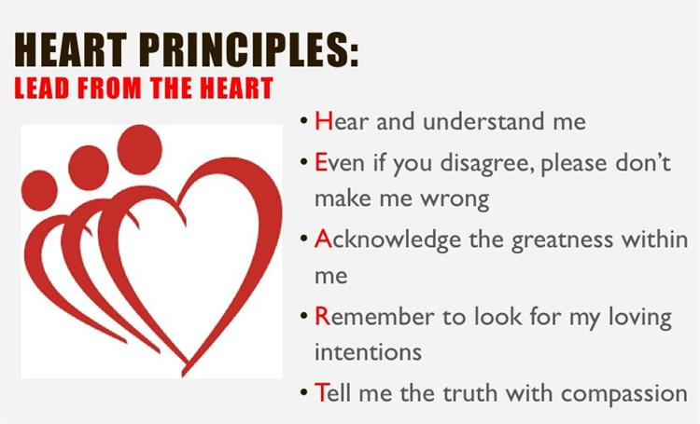
Table Talk

Talk about a time when you felt proud to be a member of this local church.

_______________________________________________________
_______________________________________________________
_______________________________________________________
_______________________________________________________
_______________________________________________________
_______________________________________________________

What do you hope will emerge as our local church’s response to this issue (all ideas will be forwarded to church leadership)?

_______________________________________________________
_______________________________________________________
_______________________________________________________
_______________________________________________________
_______________________________________________________
_______________________________________________________

What 3 things from this list can the entire table agree upon?

_______________________________________________________
_______________________________________________________
_______________________________________________________

Group: Are there things from THIS list that we can ALL agree upon?

